**ANDROID APPLICATION THAT WRITES DATA TO THE SD CARD**

##### Aim:

To develop a Android Application that writes data to the SD Card.

##### Procedure:

**Creating a New project:**

* + Open Android Studio and then click on **File -> New -> New project.**

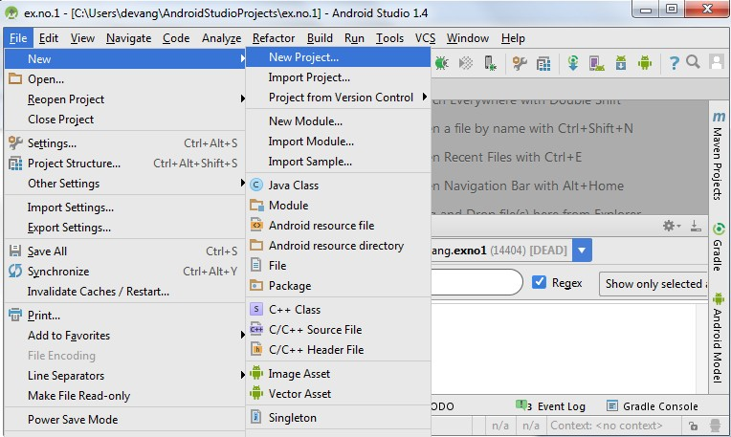

* + Then type the Application name as “**ex.no.9″** and click **Next.**

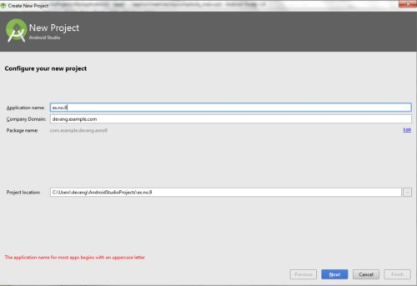

* + Then select the **Minimum SDK** as shown below and click **Next**.

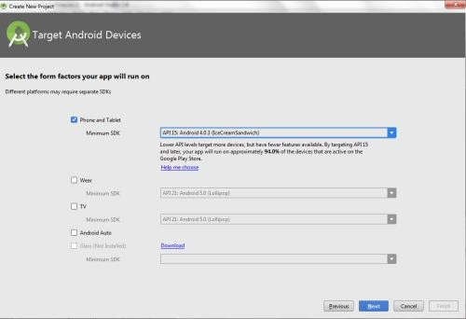

* + Then select the **Empty Activity** and click **Next.**

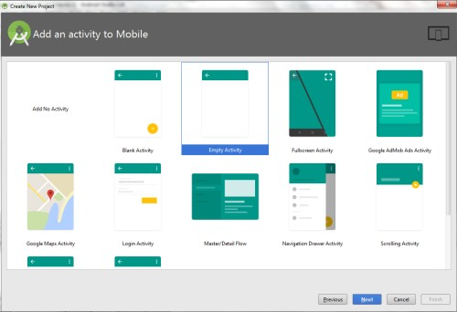

* + Finally click F**inish**.

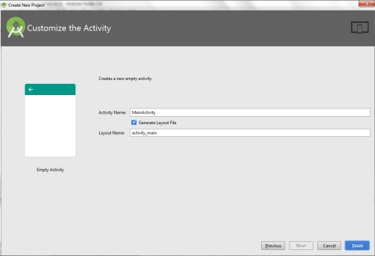

* + It will take some time to build and load the project.
  + After completion it will look as given below.

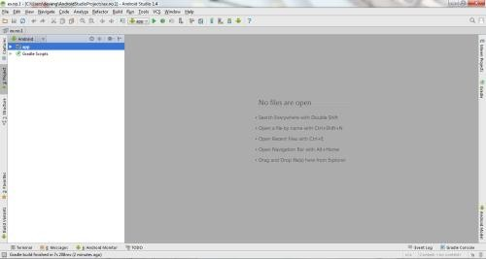

**Designing layout for the Android Application:**

* + Click on **app -> res -> layout -> activity_main.xml.**

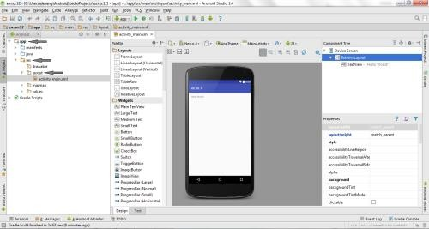

* + Now click on **Text** as shown below.

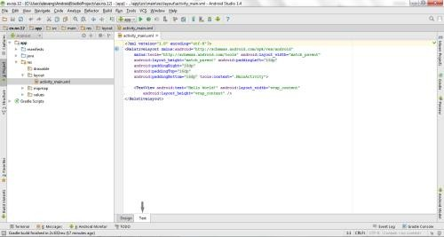

* + Then delete the code which is there and type the code as given below.

##### Code for Activity_main.xml:

<?xml version="1.0" encoding="utf-8"?>

<LinearLayout [xmlns:android="http://schemas.android.com/apk/res/android"](http://schemas.android.com/apk/res/android) android:layout_width="match_parent" android:layout_height="match_parent"

android:layout_margin="20dp" android:orientation="vertical">

<EditText

android:id="@+id/editText" android:layout_width="match_parent" android:layout_height="wrap_content" android:singleLine="true" android:textSize="30dp" />

<Button

android:id="@+id/button" android:layout_width="match_parent" android:layout_height="wrap_content" android:layout_margin="10dp" android:text="Write Data" android:textSize="30dp" />

<Button

android:id="@+id/button2" android:layout_width="match_parent" android:layout_height="wrap_content" android:layout_margin="10dp" android:text="Read data" android:textSize="30dp" />

<Button

android:id="@+id/button3" android:layout_width="match_parent" android:layout_height="wrap_content" android:layout_margin="10dp"

android:text="Clear" android:textSize="30dp" />

</LinearLayout>

* + Now click on **Design** and your application will look as given below.

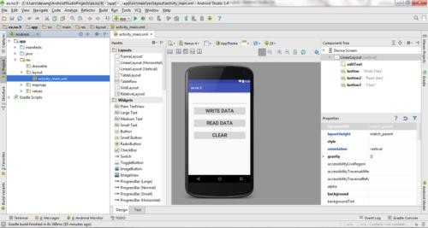

* + So now the designing part is completed.

**Adding permissions in Manifest for the Android Application:**

* + Click on **app -> manifests -> AndroidManifest.xml**

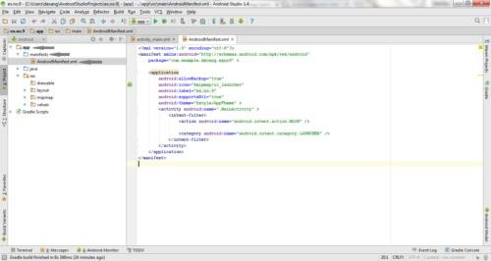

* + Now include the **WRITE_EXTERNAL_STORAGE** permissions in the AndroidManifest.xml file as shown below

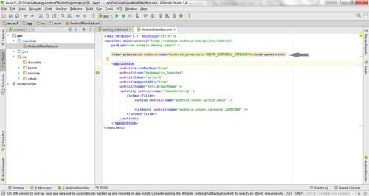

**Code for AndroidManifest.xml:**

<?xml version="1.0" encoding="utf-8"?>

<manifest [xmlns:android="http://schemas.android.com/apk/res/android"](http://schemas.android.com/apk/res/android) package="com.example.exno9" >

<uses-permission android:name="android.permission.WRITE_EXTERNAL_STORAGE"></uses-permission>

<application

android:allowBackup="true" android:icon="@mipmap/ic_launcher" android:label="@string/app_name" android:supportsRtl="true" android:theme="@style/AppTheme" >

<activity android:name=".MainActivity" >

<intent-filter>

<action android:name="android.intent.action.MAIN" />

<category android:name="android.intent.category.LAUNCHER" />

</intent-filter>

</activity>

</application>

</manifest>

* + So now the Permissions are added in the Manifest.

**Java Coding for the Android Application:**

* + Click on **app -> java -> com.example.exno9 -> MainActivity.**

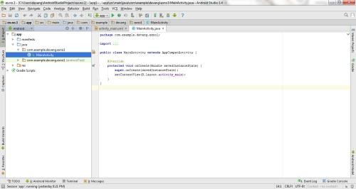

* + Then delete the code which is there and type the code as given below.

##### Code for MainActivity.java:

package com.example.exno9; import android.os.Bundle;

import android.support.v7.app.AppCompatActivity; import android.view.View;

import android.widget.Button; import android.widget.EditText; import android.widget.Toast;

import java.io.BufferedReader; import java.io.File;

import java.io.FileInputStream; import java.io.FileOutputStream; import java.io.InputStreamReader;

public class MainActivity extends AppCompatActivity

{

EditText e1;

Button write,read,clear; @Override

protected void onCreate(Bundle savedInstanceState)

{

super.onCreate(savedInstanceState); setContentView(R.layout.activity_main);

e1= (EditText) findViewById(R.id.editText); write= (Button) findViewById(R.id.button); read= (Button) findViewById(R.id.button2); clear= (Button) findViewById(R.id.button3);

write.setOnClickListener(new View.OnClickListener()

{

@Override

public void onClick(View v)

{

String message=e1.getText().toString(); try

{

File f=new File("/sdcard/myfile.txt"); f.createNewFile();

FileOutputStream fout=new FileOutputStream(f); fout.write(message.getBytes());

fout.close(); Toast.makeText(getBaseContext(),"Data Written in

SDCARD",Toast.LENGTH_LONG).show();

}

catch (Exception e)

{

Toast.makeText(getBaseContext(),e.getMessage(),Toast.LENGT

H_LONG).show();

}

}

});

read.setOnClickListener(new View.OnClickListener()

{

@Override

public void onClick(View v)

{

String message; String buf = ""; try

{

File f = new File("/sdcard/myfile.txt"); FileInputStream fin = new FileInputStream(f); BufferedReader br = new BufferedReader(new

InputStreamReader(fin));

while ((message = br.readLine()) != null)

{

buf += message;

}

e1.setText(buf); br.close();

fin.close(); Toast.makeText(getBaseContext(),"Data Recived from

SDCARD",Toast.LENGTH_LONG).show();

}

catch (Exception e)

{

Toast.makeText(getBaseContext(), e.getMessage(), Toast.LENGTH_LONG).show();

}

}

});

clear.setOnClickListener(new View.OnClickListener()

{

@Override

public void onClick(View v)

{

e1.setText("");

}

});

}}

* + So now the Coding part is also completed.
  + Now run the application to see the output.

##### Output:

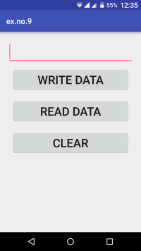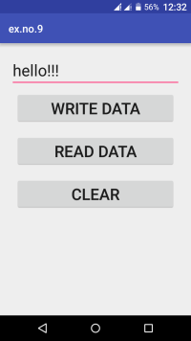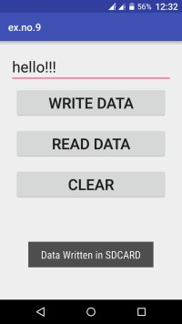

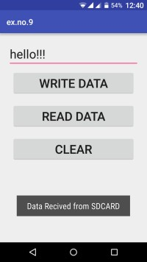

##### Result:

Thus Android Application that writes data to the SD Card is developed and executed successfully.

##### EXERCISE 8.1:

Develop an android application to read and write data on internal storage. [10]

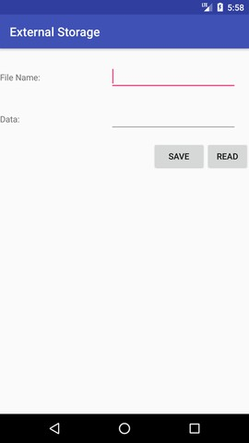

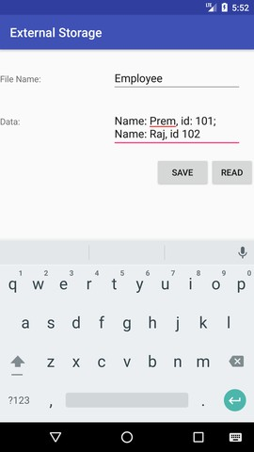

##### RESOURCES:

<https://www.codingconnect.net/mobile-application-development-lab/> <https://www.javatpoint.com/android-tutorial> <https://www.tutorialspoint.com/android> <https://developer.android.com/guide> [Https://developer.Android.com/training/basics/firstapp/creating-project](https://developer.android.com/training/basics/firstapp/creating-project)

[Https://www.raywenderlich.com/120177/beginning-Android-development-tutorial-](https://www.raywenderlich.com/120177/beginning-Android-development-tutorial-installingAndroid-studio) [installingAndroid-studio](https://www.raywenderlich.com/120177/beginning-Android-development-tutorial-installingAndroid-studio) <https://www.youtube.com/playlist?list=PLS1QulWo1RIbb1cYyzZpLFCKvdYV_yJ-E> [Https://www.udemy.com/java-tutorial/](https://www.udemy.com/java-tutorial/)

[Https://www.w3schools.com/xml/](https://www.w3schools.com/xml/) [Http://www.Androidguys.com/](http://www.androidguys.com/)